1. **Creating Hello World Application**

**Steps:**

**1. Click New Project, the New Project Dialog box appears.**

**2. Choose Empty Views Activity then click Next.**

**3. Specify the Name of your project, Select the Language as Java, and Select the SDK as API 24(“Nougat”,Android 7.0).Click Finish Button.**

**4. Update the following code in activity_main.xml and MainActivity.java**

**=>Coding part of Activity_main.xml**

*<?*xml version="1.0" encoding="utf-8"*?>*<androidx.constraintlayout.widget.ConstraintLayout xmlns:android="http://schemas.android.com/apk/res/android"  
 xmlns:app="http://schemas.android.com/apk/res-auto"  
 xmlns:tools="http://schemas.android.com/tools"  
 android:id="@+id/main"  
 android:layout_width="match_parent"  
 android:layout_height="match_parent"  
 tools:context=".MainActivity">  
  
 <TextView  
 android:layout_width="wrap_content"  
 android:layout_height="wrap_content"  
 **android:text="Hello World!"  
 android:textSize="40sp"  
 android:textStyle="bold|italic"** app:layout_constraintBottom_toBottomOf="parent"  
 app:layout_constraintEnd_toEndOf="parent"  
 app:layout_constraintStart_toStartOf="parent"  
 app:layout_constraintTop_toTopOf="parent" />  
  
</androidx.constraintlayout.widget.ConstraintLayout>

**=>Coding part of MainActivity.java**

package com.example.loginapplication;  
  
import android.os.Bundle;  
import androidx.activity.EdgeToEdge;  
import androidx.appcompat.app.AppCompatActivity;  
import androidx.core.graphics.Insets;  
import androidx.core.view.ViewCompat;  
import androidx.core.view.WindowInsetsCompat;  
  
public class MainActivity extends AppCompatActivity {  
  
 @Override  
 protected void onCreate(Bundle savedInstanceState) {  
 super.onCreate(savedInstanceState);  
 EdgeToEdge.*enable*(this);  
 setContentView(R.layout.*activity_main*);  
 }  
}

**=>Output of the program**

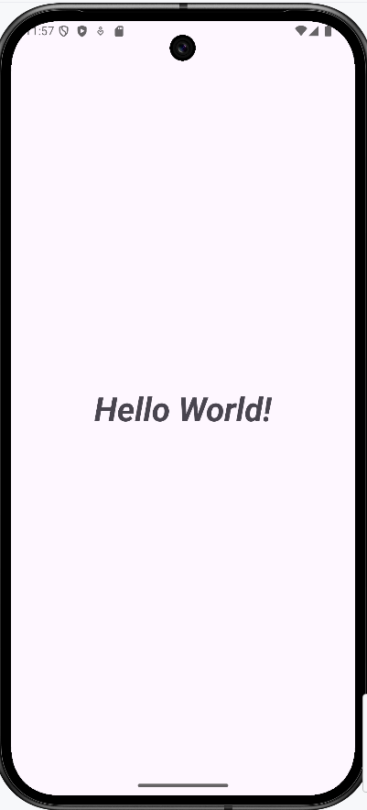

**2. Creating an Application that displays message based on screen orientation**

**Step 1: Click New Project, the New Project Dialog box appears.**

**2. Choose Empty Views Activity then click Next.**

**3. Specify the Name of your project, Select the Language as Java, and Select the SDK as API 24(“Nougat”,Android 7.0).Click Finish Button.**

**4. Update the following code in activity_main.xml and MainActivity.java**

**=>Coding part of Activity_main.xml**

*<?*xml version="1.0" encoding="utf-8"*?>*<androidx.constraintlayout.widget.ConstraintLayout xmlns:android="http://schemas.android.com/apk/res/android"  
 xmlns:app="http://schemas.android.com/apk/res-auto"  
 xmlns:tools="http://schemas.android.com/tools"  
 android:id="@+id/main"  
 android:layout_width="match_parent"  
 android:layout_height="match_parent"  
 tools:context=".MainActivity">  
  
 <TextView  
 android:id="@+id/textView"  
 android:layout_width="wrap_content"  
 android:layout_height="wrap_content"  
 **android:text="This is Portrait"  
 android:textSize="40sp"**  
 app:layout_constraintBottom_toBottomOf="parent"  
 app:layout_constraintEnd_toEndOf="parent"  
 app:layout_constraintHorizontal_bias="0.496"  
 app:layout_constraintStart_toStartOf="parent"  
 app:layout_constraintTop_toTopOf="parent"  
 app:layout_constraintVertical_bias="0.25" />  
  
 <Button  
 android:id="@+id/button"  
 android:layout_width="wrap_content"  
 android:layout_height="wrap_content"  
 **android:onClick="onClick"  
 android:text="Launch new activity"**  
 app:layout_constraintBottom_toBottomOf="parent"  
 app:layout_constraintEnd_toEndOf="parent"  
 app:layout_constraintHorizontal_bias="0.497"  
 app:layout_constraintStart_toStartOf="parent"  
 app:layout_constraintTop_toTopOf="parent"  
 app:layout_constraintVertical_bias="0.499" />  
  
</androidx.constraintlayout.widget.ConstraintLayout>

**=>Coding part of MainActivity.java**

package com.example.orientation;  
  
**import android.content.Intent;**  
import android.os.Bundle;  
**import android.view.View;**  
import androidx.activity.EdgeToEdge;  
import androidx.appcompat.app.AppCompatActivity;  
import androidx.core.graphics.Insets;  
import androidx.core.view.ViewCompat;  
import androidx.core.view.WindowInsetsCompat;  
  
public class MainActivity extends AppCompatActivity {  
  
 @Override  
 protected void onCreate(Bundle savedInstanceState) {  
 super.onCreate(savedInstanceState);  
 EdgeToEdge.*enable*(this);  
 setContentView(R.layout.*activity_main*);  
 }  
  
 **public void onClick(View v){  
 Intent intent=new Intent(MainActivity.this,Nextactivity.class);  
 startActivity(intent);  
 }**  
}

**Step 2: Create another new empty views activity and give the name as Nextactivity (Go to app>> New>>Activity>>Empty Views Activity)**

**=>Coding part of Activity_nextactivity.xml**

*<?*xml version="1.0" encoding="utf-8"*?>*<androidx.constraintlayout.widget.ConstraintLayout xmlns:android="http://schemas.android.com/apk/res/android"  
 xmlns:app="http://schemas.android.com/apk/res-auto"  
 xmlns:tools="http://schemas.android.com/tools"  
 android:id="@+id/main"  
 android:layout_width="match_parent"  
 android:layout_height="match_parent"  
 tools:context=".Nextactivity">  
  
 <TextView  
 android:id="@+id/textView3"  
 android:layout_width="wrap_content"  
 android:layout_height="wrap_content"  
 **android:text="This is Landscape Orientation"  
 android:textSize="30sp"**  
 app:layout_constraintBottom_toBottomOf="parent"  
 app:layout_constraintEnd_toEndOf="parent"  
 app:layout_constraintStart_toStartOf="parent"  
 app:layout_constraintTop_toTopOf="parent" />  
</androidx.constraintlayout.widget.ConstraintLayout>

**Step 3: Add the screen orientation values in AndroidManifest.xml**

**=>Coding part of AndroidManifest.xml**

*<?*xml version="1.0" encoding="utf-8"*?>*<manifest xmlns:android="http://schemas.android.com/apk/res/android"  
 xmlns:tools="http://schemas.android.com/tools">  
  
 <application  
 android:allowBackup="true"  
 android:dataExtractionRules="@xml/data_extraction_rules"  
 android:fullBackupContent="@xml/backup_rules"  
 android:icon="@mipmap/ic_launcher"  
 android:label="@string/app_name"  
 android:roundIcon="@mipmap/ic_launcher_round"  
 android:supportsRtl="true"  
 android:theme="@style/Theme.Orientation"  
 tools:targetApi="31">  
 <activity  
 android:name=".Nextactivity"  
 android:exported="false"  
 **android:screenOrientation="landscape"**  
 />  
 <activity  
 android:name=".MainActivity"  
 android:exported="true"  
 **android:screenOrientation="portrait"** >  
 <intent-filter>  
 <action android:name="android.intent.action.MAIN" />  
  
 <category android:name="android.intent.category.LAUNCHER" />  
 </intent-filter>  
 </activity>  
 </application>  
</manifest>

**=>Output of the program**

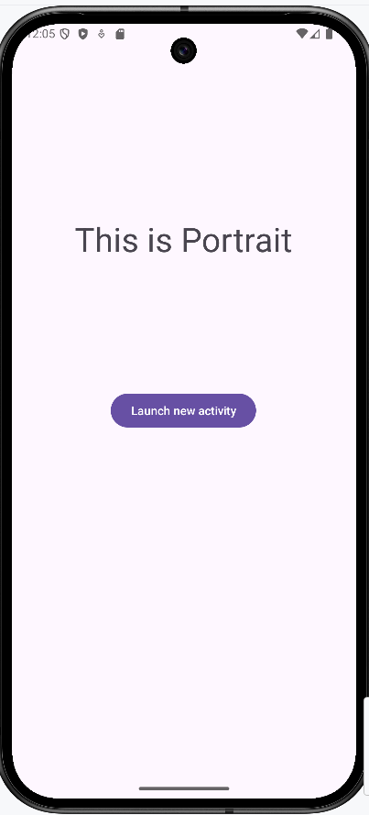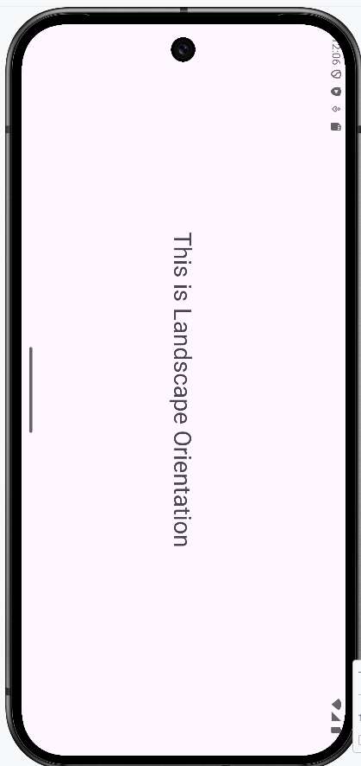

**3. Create and Application to develop Login window using UI controls**

**Step 1: Click New Project, the New Project Dialog box appears.**

**2. Choose Empty Views Activity then click Next.**

**3. Specify the Name of your project, Select the Language as Java, and Select the SDK as API 24(“Nougat”,Android 7.0).Click Finish Button.**

**4. Update the following code in activity_main.xml and MainActivity.java**

**=>Coding part of Activity_main.xml**

*<?*xml version="1.0" encoding="utf-8"*?>*<LinearLayout xmlns:android="http://schemas.android.com/apk/res/android"  
 xmlns:app="http://schemas.android.com/apk/res-auto"  
 xmlns:tools="http://schemas.android.com/tools"  
 android:id="@+id/main"  
 android:layout_width="match_parent"  
 android:layout_height="match_parent"  
 **android:orientation="vertical"**  
 tools:context=".MainActivity">  
  
 <TextView  
  **android:id="@+id/tvTitle"**  
 android:layout_width="wrap_content"  
 android:layout_height="wrap_content"  
 **android:layout_gravity="center"  
 android:layout_marginTop="200dp"  
 android:text="Login Form"  
 android:textSize="40sp"** />  
  
 <TextView  
 **android:id="@+id/tvUserName"**  
 android:layout_width="wrap_content"  
 android:layout_height="wrap_content"  
 **android:text="User Name"  
 android:textSize="24sp"** />  
  
 <EditText  
 **android:id="@+id/etUserName"**  
 android:layout_width="match_parent"  
 android:layout_height="wrap_content"  
 **android:hint="Enter the User Name"  
 android:inputType="text"  
 android:textSize="24sp"** />  
  
 <TextView  
 **android:id="@+id/tvPassword"**  
 android:layout_width="wrap_content"  
 android:layout_height="wrap_content"  
  **android:text="Password"  
 android:textSize="24sp"** />  
  
 <EditText  
  **android:id="@+id/etPassword"**  
  **android:layout_width="match_parent"**  
 android:layout_height="wrap_content"  
 **android:hint="Enter the Password"  
 android:inputType="textPassword"  
 android:textSize="24sp"** />  
  
 <Button  
 **android:id="@+id/btnLogin"**  
 android:layout_width="wrap_content"  
 android:layout_height="wrap_content"  
  **android:text="Login"  
 android:layout_gravity="center"** />  
  
</LinearLayout>

**=>Coding part of MainActivity.java**

package com.example.loginapplication;  
  
import android.os.Bundle;  
import androidx.activity.EdgeToEdge;  
import androidx.appcompat.app.AppCompatActivity;  
import androidx.core.graphics.Insets;  
import androidx.core.view.ViewCompat;  
import androidx.core.view.WindowInsetsCompat;  
  
public class MainActivity extends AppCompatActivity {  
  
 @Override  
 protected void onCreate(Bundle savedInstanceState) {  
 super.onCreate(savedInstanceState);  
 EdgeToEdge.*enable*(this);  
 setContentView(R.layout.*activity_main*);  
 }  
}

**=>Output of the program**

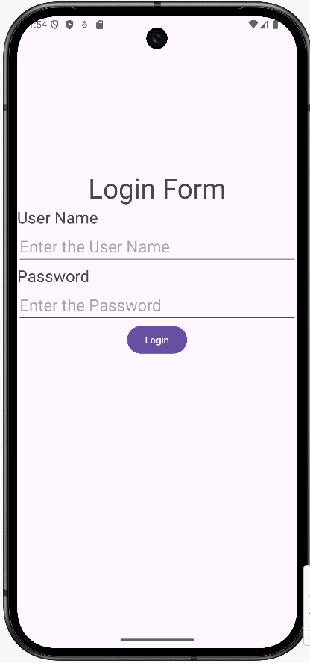

**4. Create and Application to implement new activity using explicit intent and implicit intent**

**Step 1: Click New Project, the New Project Dialog box appears.**

**2. Choose Empty Views Activity then click Next.**

**3. Specify the Name of your project, Select the Language as Java, and Select the SDK as API 24(“Nougat”,Android 7.0).Click Finish Button.**

**4. Update the following code in activity_main.xml and MainActivity.java**

**=>Coding part of Activity_main.xml**

*<?*xml version="1.0" encoding="utf-8"*?>*<LinearLayout xmlns:android="http://schemas.android.com/apk/res/android"  
 xmlns:app="http://schemas.android.com/apk/res-auto"  
 xmlns:tools="http://schemas.android.com/tools"  
 android:id="@+id/main"  
 android:layout_width="match_parent"  
 android:layout_height="match_parent"  
 **android:orientation="vertical"**  
 tools:context=".MainActivity">  
  
 <TextView  
 android:layout_width="wrap_content"  
 android:layout_height="wrap_content"  
 **android:text="Explicit Activity"  
 android:textSize="30sp"  
 android:layout_gravity="center"  
 android:layout_marginTop="200dp"**  
 />  
  
 <Button  
 android:id="@+id/btnExplicitContent"  
  **android:layout_width="match_parent"**  
 android:layout_height="wrap_content"  
 **android:layout_marginTop="200dp"**  
 **android:onClick="onClick"**  
 **android:text="Explicit Activity"** />  
  
</LinearLayout>

**=>Coding part of MainActivity.java**

package com.example.implicitexplicit;  
**import android.content.Intent;  
import android.view.View;**  
import android.os.Bundle;  
  
import androidx.activity.EdgeToEdge;  
import androidx.appcompat.app.AppCompatActivity;  
import androidx.core.graphics.Insets;  
import androidx.core.view.ViewCompat;  
import androidx.core.view.WindowInsetsCompat;  
  
  
  
public class MainActivity extends AppCompatActivity {  
  
 @Override  
 protected void onCreate(Bundle savedInstanceState) {  
 super.onCreate(savedInstanceState);  
 EdgeToEdge.*enable*(this);  
 setContentView(R.layout.*activity_main*);  
 ViewCompat.*setOnApplyWindowInsetsListener*(findViewById(R.id.*main*), (v, insets) -> {  
 Insets systemBars = insets.getInsets(WindowInsetsCompat.Type.*systemBars*());  
 v.setPadding(systemBars.left, systemBars.top, systemBars.right, systemBars.bottom);  
 return insets;  
 });  
 }

**public void onClick(View view) {  
 Intent intent = new Intent(MainActivity.this, NextActivity.class);  
 startActivity(intent);  
 }**  
  
}

**Step 2: Create another new empty views activity and give the name as Nextactivity (Go to app>> New>>Activity>>Empty Views Activity)**

**Coding part of activity_next.xml**

*<?*xml version="1.0" encoding="utf-8"*?>*<LinearLayout xmlns:android="http://schemas.android.com/apk/res/android"  
 xmlns:app="http://schemas.android.com/apk/res-auto"  
 xmlns:tools="http://schemas.android.com/tools"  
 android:id="@+id/main"  
 android:layout_width="match_parent"  
 android:layout_height="match_parent"  
 **android:orientation="vertical"**  
 tools:context=".NextActivity">  
  
 <TextView  
 android:layout_width="wrap_content"  
 android:layout_height="wrap_content"  
 **android:text="Implicit Activity"  
 android:textSize="30sp"  
 android:layout_gravity="center"  
 android:layout_marginTop="200dp"**  
 />  
  
 <Button  
 android:id="@+id/btnImplicitContent"  
 android:layout_width="match_parent"  
 android:layout_height="wrap_content"  
 **android:layout_marginTop="200dp"  
 android:onClick="onClick"  
 android:text="Implicit Activity"** />  
  
</LinearLayout>

**=>Coding part of NextActivity.java**

package com.example.implicitexplicit;  
  
import android.os.Bundle;  
import androidx.activity.EdgeToEdge;  
import androidx.appcompat.app.AppCompatActivity;  
import androidx.core.graphics.Insets;  
import androidx.core.view.ViewCompat;  
import androidx.core.view.WindowInsetsCompat;  
**import android.content.Intent;  
import android.net.Uri;  
import android.view.View;**  
  
public class NextActivity extends AppCompatActivity {  
  
 @Override  
 protected void onCreate(Bundle savedInstanceState) {  
 super.onCreate(savedInstanceState);  
 EdgeToEdge.*enable*(this);  
 setContentView(R.layout.*activity_next*);  
 ViewCompat.*setOnApplyWindowInsetsListener*(findViewById(R.id.*main*), (v, insets) -> {  
 Insets systemBars = insets.getInsets(WindowInsetsCompat.Type.*systemBars*());  
 v.setPadding(systemBars.left, systemBars.top, systemBars.right, systemBars.bottom);  
 return insets;  
 });  
  
 }  
  
  
 **public void onClick(View view) {  
 Uri webpage= Uri.*parse*("http://www.google.com");  
 Intent intent = new Intent(Intent.*ACTION_VIEW*, webpage);  
 startActivity(intent);  
 }**  
  
}

**=>Output of the program**

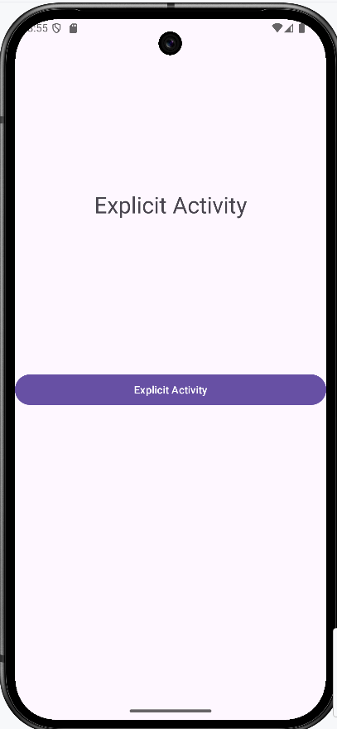 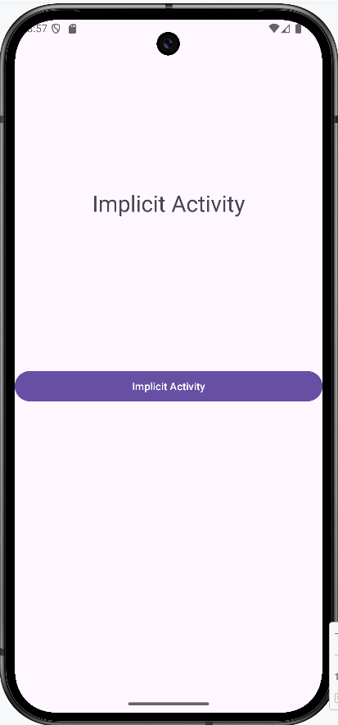 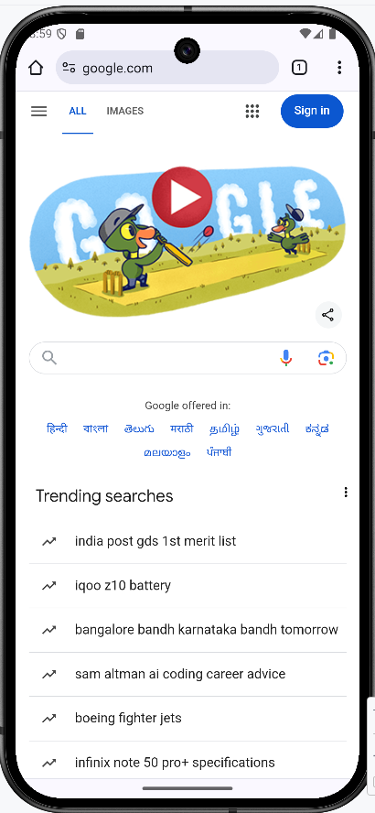

**6. Create and Application to show all views**

**Steps:**

**1. Click New Project, the New Project Dialog box appears.**

**2. Choose Empty Views Activity then click Next.**

**3. Specify the Name of your project, Select the Language as Java, and Select the SDK as API 24(“Nougat”,Android 7.0).Click Finish Button.**

**4. Update the following code in activity_main.xml and MainActivity.java**

**=>Coding part of Activity_main.xml**

*<?*xml version="1.0" encoding="utf-8"*?>*<ScrollView xmlns:android="http://schemas.android.com/apk/res/android"  
 xmlns:app="http://schemas.android.com/apk/res-auto"  
 xmlns:tools="http://schemas.android.com/tools"  
 android:id="@+id/main"  
 android:layout_width="match_parent"  
 android:layout_height="match_parent"  
 tools:context=".MainActivity">  
  
 <LinearLayout  
 android:layout_width="match_parent"  
 android:layout_height="wrap_content"  
 android:orientation="vertical"  
 android:padding="16dp">  
  
 <TextView  
 android:id="@+id/textView"  
 android:layout_width="wrap_content"  
 android:layout_height="wrap_content"  
 android:text="This is a TextView"  
 android:textSize="18sp"  
 android:layout_marginBottom="16dp"/>  
  
 <EditText  
 android:id="@+id/editText"  
 android:layout_width="match_parent"  
 android:layout_height="wrap_content"  
 android:hint="Enter your text here"  
 android:layout_marginBottom="16dp" />  
  
 <Button  
 android:id="@+id/button"  
 android:layout_width="wrap_content"  
 android:layout_height="wrap_content"  
 android:text="Click Me"  
 android:layout_marginBottom="16dp" />  
  
 <CheckBox  
 android:id="@+id/checkbox"  
 android:layout_width="wrap_content"  
 android:layout_height="wrap_content"  
 android:text="Check Me"  
 android:layout_marginBottom="16dp" />  
 <TextView  
 android:id="@+id/textView1"  
 android:layout_width="wrap_content"  
 android:layout_height="wrap_content"  
 android:text="Which Section You belong to"  
 android:textSize="20sp"  
 android:layout_marginBottom="16dp"/>  
 <RadioGroup  
 android:id="@+id/radioGroup"  
 android:layout_width="wrap_content"  
 android:layout_height="wrap_content"  
 android:orientation="vertical"  
 android:layout_marginBottom="16dp" />  
  
 <RadioButton  
 android:id="@+id/radioButton1"  
 android:layout_width="wrap_content"  
 android:layout_height="wrap_content"  
 android:text="A section" />  
  
 <RadioButton  
 android:id="@+id/radioButton2"  
 android:layout_width="wrap_content"  
 android:layout_height="wrap_content"  
 android:text="B Section" />  
  
 <Switch  
 android:id="@+id/switch1"  
 android:layout_width="wrap_content"  
 android:layout_height="wrap_content"  
 android:text="Switch Testing"  
 android:layout_marginBottom="16dp"/>  
 <TextView  
 android:id="@+id/textView2"  
 android:layout_width="wrap_content"  
 android:layout_height="wrap_content"  
 android:text="Select your favourite Programming Language"  
 android:textSize="20sp"  
 android:layout_marginBottom="16dp"/>  
 <Spinner  
 android:id="@+id/spinner"  
 android:layout_width="match_parent"  
 android:layout_height="wrap_content"  
 android:layout_marginBottom="16dp"/>  
 <TextView  
 android:id="@+id/textView3"  
 android:layout_width="wrap_content"  
 android:layout_height="wrap_content"  
 android:text="Progress Bar"  
 android:textSize="20sp"  
 android:layout_marginBottom="16dp"/>  
 <ProgressBar  
 android:id="@+id/progressBar"  
 android:layout_width="match_parent"  
 android:layout_height="wrap_content"  
 style="@style/Widget.AppCompat.ProgressBar.Horizontal"  
 android:progress="25"  
 android:layout_marginBottom="16dp" />  
 <TextView  
 android:id="@+id/textView4"  
 android:layout_width="wrap_content"  
 android:layout_height="wrap_content"  
 android:text="Select the number between 1 to 50"  
 android:textSize="20sp"  
 android:layout_marginBottom="16dp"/>  
 <NumberPicker  
 android:id="@+id/numberPicker1"  
 android:layout_width="wrap_content"  
 android:layout_height="wrap_content"  
 android:layout_marginBottom="16dp"/>  
 <TextView  
 android:id="@+id/textView5"  
 android:layout_width="wrap_content"  
 android:layout_height="wrap_content"  
 android:text="Select your date of birth"  
 android:textSize="20sp"  
 android:layout_marginBottom="16dp"/>  
 <DatePicker  
 android:id="@+id/datePicker"  
 android:layout_width="wrap_content"  
 android:layout_height="wrap_content"  
 android:layout_marginBottom="16dp"/>  
 <TextView  
 android:id="@+id/textView6"  
 android:layout_width="wrap_content"  
 android:layout_height="wrap_content"  
 android:text="Set the next class hour time"  
 android:textSize="20sp"  
 android:layout_marginBottom="16dp"/>  
 <TimePicker  
 android:id="@+id/timePicker"  
 android:layout_width="wrap_content"  
 android:layout_height="wrap_content"  
 android:layout_marginBottom="16dp"/>  
  
 </LinearLayout>  
  
</ScrollView>

**=>Coding part of MainActivity.java**

package com.example.mainactivity;  
  
import android.os.Bundle;  
import android.widget.ArrayAdapter;  
import android.widget.Spinner;  
  
import androidx.activity.EdgeToEdge;  
import androidx.appcompat.app.AppCompatActivity;  
import androidx.core.graphics.Insets;  
import androidx.core.view.ViewCompat;  
import androidx.core.view.WindowInsetsCompat;  
  
import java.util.ArrayList;  
import android.widget.NumberPicker;  
  
public class MainActivity extends AppCompatActivity {  
  
 @Override  
 protected void onCreate(Bundle savedInstanceState) {  
 super.onCreate(savedInstanceState);  
 EdgeToEdge.*enable*(this);  
 setContentView(R.layout.*activity_main*);  
 ViewCompat.*setOnApplyWindowInsetsListener*(findViewById(R.id.*main*), (v, insets) -> {  
 Insets systemBars = insets.getInsets(WindowInsetsCompat.Type.*systemBars*());  
 v.setPadding(systemBars.left, systemBars.top, systemBars.right, systemBars.bottom);  
 return insets;  
 });  
 **Spinner spinner = findViewById(R.id.*spinner*);  
 ArrayList<String> arrayList = new ArrayList<>();  
 arrayList.add("Select Language");  
 arrayList.add("JAVA");  
 arrayList.add("ANDROID");  
 arrayList.add("C Language");  
 arrayList.add("CPP Language");  
 arrayList.add("Python Programming");  
  
 ArrayAdapter<String> arrayAdapter = new ArrayAdapter<String>(this,  
 android.R.layout.*simple_spinner_item*, arrayList);  
 arrayAdapter.setDropDownViewResource(android.R.layout.*simple_spinner_dropdown_item*);  
 spinner.setAdapter(arrayAdapter);  
  
  
 NumberPicker numberPicker1 = findViewById(R.id.*numberPicker1*);  
 numberPicker1.setMinValue(1);  
 numberPicker1.setMaxValue(50);**  
 }  
}

**=> Output of the program**

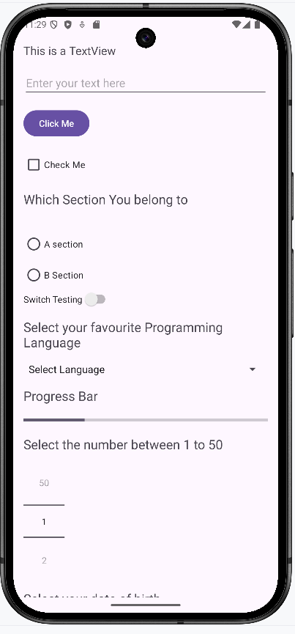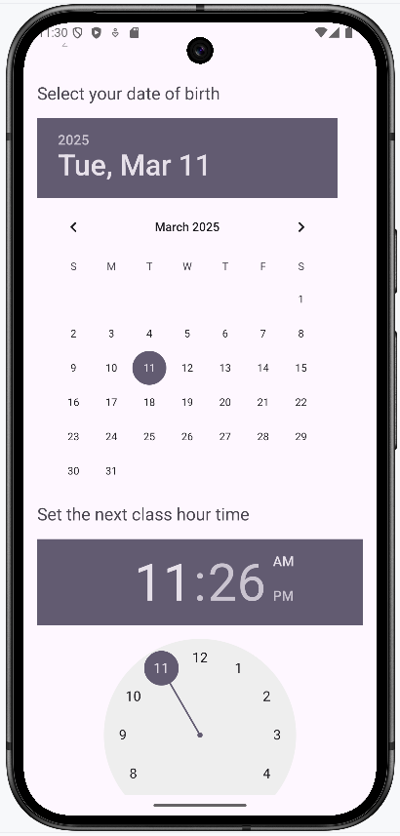

**7 Create a menu in application**

**Steps:**

**1. Click New Project, the New Project Dialog box appears.**

**2. Choose Empty Views Activity then click Next.**

**3. Specify the Name of your project, Select the Language as Java, and Select the SDK as API 24(“Nougat”,Android 7.0).Click Finish Button.**

**Steps to be followed to create the menu**

**Step1. Create Android resource directory by clicking res>>new>>Android Resource directory, give the name as menu**

**Step2. Right click menu folder click new>> Menu Resource File, give the name of the file as menus.**

**Add the following code in menus.xml**

*<?*xml version="1.0" encoding="utf-8"*?>*<menu xmlns:android="http://schemas.android.com/apk/res/android">  
 <item android:id="@+id/php" android:title="PHP"/>  
 <item android:id="@+id/java" android:title="JAVA"/>  
 <item android:id="@+id/csharp" android:title="C#"/>  
</menu>

**Step 3. =>Coding part of Activity_main.xml ( Remove Helloworld textview control)**

*<?*xml version="1.0" encoding="utf-8"*?>*<androidx.constraintlayout.widget.ConstraintLayout xmlns:android="http://schemas.android.com/apk/res/android"  
 xmlns:app="http://schemas.android.com/apk/res-auto"  
 xmlns:tools="http://schemas.android.com/tools"  
 android:id="@+id/main"  
 android:layout_width="match_parent"  
 android:layout_height="match_parent"  
 tools:context=".MainActivity">  
</androidx.constraintlayout.widget.ConstraintLayout>

**Step 4. =>Coding part of MainActivity.java**

package com.example.menuapp;  
  
import android.os.Bundle;  
import androidx.activity.EdgeToEdge;  
import androidx.appcompat.app.AppCompatActivity;  
import androidx.core.graphics.Insets;  
import androidx.core.view.ViewCompat;  
import androidx.core.view.WindowInsetsCompat;  
**import android.view.Menu;  
import android.view.MenuInflater;  
import android.view.MenuItem;  
import android.widget.Toast;**  
  
  
public class MainActivity extends AppCompatActivity {  
  
 @Override  
 protected void onCreate(Bundle savedInstanceState) {  
 super.onCreate(savedInstanceState);  
 EdgeToEdge.*enable*(this);  
 setContentView(R.layout.*activity_main*);  
 }

@Override

**public boolean onCreatePanelMenu(int featureId,Menu menu)  
 {  
 MenuInflater inflater=getMenuInflater();   
 inflater.inflate(R.menu.*menus*,menu);  
 return true;  
 }  
 @Override  
 public boolean onOptionsItemSelected(MenuItem item)  
 {  
 if(item.getItemId()==R.id.*php*) {  
 Toast.*makeText*(this, "Php Page", Toast.*LENGTH_SHORT*).show();  
 }  
 if(item.getItemId()==R.id.*java*) {  
 Toast.*makeText*(this, "Java Page", Toast.*LENGTH_SHORT*).show();  
 }  
 if(item.getItemId()==R.id.*csharp*) {  
 Toast.*makeText*(this, "C# Page", Toast.*LENGTH_SHORT*).show();  
 }  
 return true;  
 }**  
 }

**Step 5. Change the theme value AndroidManifest.xml file**

*<?*xml version="1.0" encoding="utf-8"*?>*<manifest xmlns:android="http://schemas.android.com/apk/res/android"  
 xmlns:tools="http://schemas.android.com/tools">  
 <application  
 android:allowBackup="true"  
 android:dataExtractionRules="@xml/data_extraction_rules"  
 android:fullBackupContent="@xml/backup_rules"  
 android:icon="@mipmap/ic_launcher"  
 android:label="@string/app_name"  
 android:roundIcon="@mipmap/ic_launcher_round"  
 android:supportsRtl="true"  
 **android:theme="@style/Theme.AppCompat.Light"**  
 tools:targetApi="31">  
 <activity  
 android:name=".MainActivity"  
 android:exported="true">  
 <intent-filter>  
 <action android:name="android.intent.action.MAIN" />  
  
 <category android:name="android.intent.category.LAUNCHER"/>  
 </intent-filter>  
 </activity>  
 </application>  
</manifest>

**=>Output of the program**

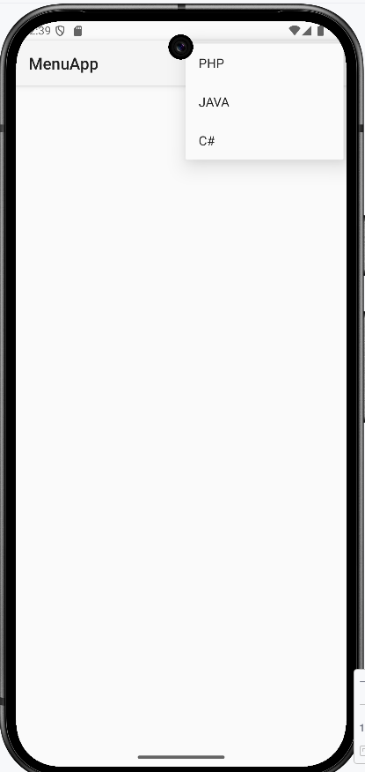

**11. Create an application to send Email**

**Steps:**

**1. Click New Project, the New Project Dialog box appears.**

**2. Choose Empty Views Activity then click Next.**

**3. Specify the Name of your project, Select the Language as Java, and Select the SDK as API 24(“Nougat”,Android 7.0).Click Finish Button.**

**4. Update the following code in activity_main.xml and MainActivity.java**

**=>Coding part of Activity_main.xml**

*<?*xml version="1.0" encoding="utf-8"*?>*<LinearLayout xmlns:android="http://schemas.android.com/apk/res/android"  
 xmlns:tools="http://schemas.android.com/tools"  
 android:layout_width="match_parent"  
 android:layout_height="match_parent"  
 **android:orientation="vertical"**  
 tools:context=".MainActivity">  
 <EditText  
 **android:id="@+id/etTo"**  
 android:layout_width="match_parent"  
 android:layout_height="wrap_content"  
 **android:hint="To"/>**  
 <EditText  
 **android:id="@+id/etSubject"**  
 android:layout_width="match_parent"  
 android:layout_height="wrap_content"  
 **android:layout_below="@id/etTo"  
 android:hint="Subject"/>**  
 <EditText  
 **android:id="@+id/etMessage"**  
 android:layout_width="match_parent"  
 android:layout_height="wrap_content"  
 **android:layout_below="@id/etSubject"  
 android:hint="Message"/>**  
 <Button  
 **android:id="@+id/btnSend"**  
 android:layout_width="wrap_content"  
 android:layout_height="wrap_content"  
 **android:onClick="onClick"  
 android:layout_below="@id/etMessage"  
 android:text="Send"/>**  
</LinearLayout>

**=>Coding part of MainActivity.java**

import androidx.appcompat.app.AppCompatActivity;  
import android.content.Intent;  
import android.os.Bundle;  
import android.view.View;  
import android.widget.EditText;  
public class MainActivity extends AppCompatActivity {  
 **EditText etTo, etSubject, etMessage;**  
  
 @Override  
 protected void onCreate(Bundle savedInstanceState)  
 {  
 super.onCreate(savedInstanceState);  
 setContentView(R.layout.*activity_main*);  
 **etTo = findViewById(R.id.*etTo*);  
 etSubject = findViewById(R.id.*etSubject*);  
 etMessage = findViewById(R.id.*etMessage*);** }  
 **public void onClick(View v){  
 String strTo = etTo.getText().toString().trim();  
 String strSubject = etSubject.getText().toString().trim();  
 String strMessage = etMessage.getText().toString().trim();  
 Intent intent = new Intent(Intent.*ACTION_SEND*);  
 intent.setType("text/plain");  
 intent.putExtra(Intent.*EXTRA_EMAIL*, new String[]{strTo});  
 intent.putExtra(Intent.*EXTRA_SUBJECT*, strSubject);  
 intent.putExtra(Intent.*EXTRA_TEXT*, strMessage);  
 if (intent.resolveActivity(getPackageManager()) != null)  
 {  
 startActivity(Intent.*createChooser*(intent, "Choose an email client"));  
 }  
 }**}

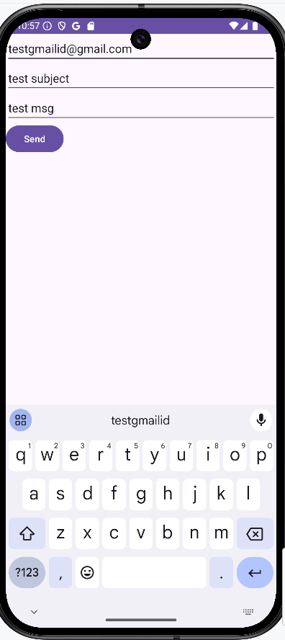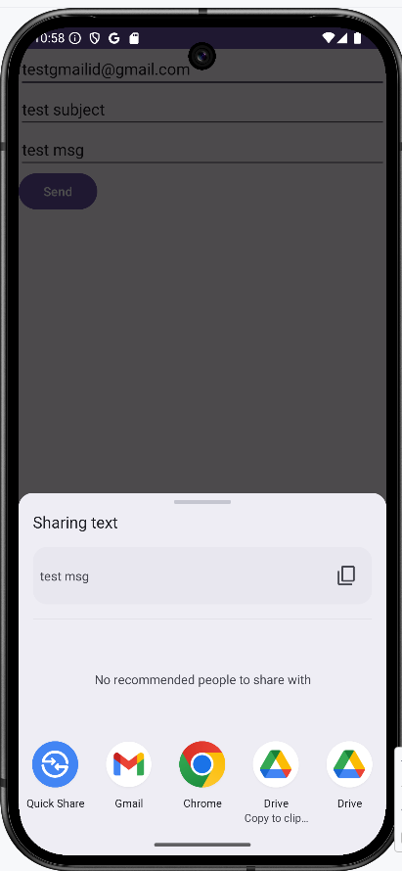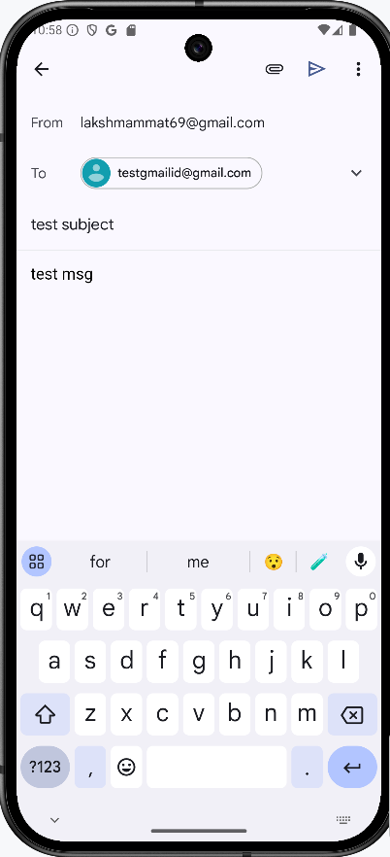

**13. Create an Application with Login module. Check User name and password. On successful login change textview “Login Successful”. On Login fail alert using Toast “Login Fail”**

**Steps:**

**1. Click New Project, the New Project Dialog box appears.**

**2. Choose Empty Views Activity then click Next.**

**3. Specify the Name of your project, Select the Language as Java, and Select the SDK as API 24(“Nougat”,Android 7.0).Click Finish Button.**

**4. Update the following code in activity_main.xml and MainActivity.java**

**=>Coding part of Activity_main.xml**

*<?*xml version="1.0" encoding="utf-8"*?>*<LinearLayout xmlns:android="http://schemas.android.com/apk/res/android"  
 xmlns:app="http://schemas.android.com/apk/res-auto"  
 xmlns:tools="http://schemas.android.com/tools"  
 android:id="@+id/main"  
 **android:layout_width="match_parent"  
 android:layout_height="match_parent"  
 android:orientation="vertical"**  
 tools:context=".MainActivity">  
  
 <TextView  
 android:id="@+id/tvTitle"  
 android:layout_width="wrap_content"  
 android:layout_height="wrap_content"  
  **android:layout_gravity="center"  
 android:layout_marginTop="200dp"  
 android:text="Login Form"  
 android:textSize="40sp"** />  
  
 <TextView  
 android:id="@+id/tvUserName"  
 android:layout_width="wrap_content"  
 android:layout_height="wrap_content"  
 **android:text="User Name"  
 android:textSize="24sp"** />  
  
 <EditText  
 android:id="@+id/etUserName"  
 android:layout_width="match_parent"  
 android:layout_height="wrap_content"  
 **android:hint="Enter the User Name"  
 android:inputType="text"  
 android:textSize="24sp"** />  
  
 <TextView  
 android:id="@+id/tvPassword"  
 android:layout_width="wrap_content"  
 android:layout_height="wrap_content"  
 **android:text="Password"  
 android:textSize="24sp"** />  
  
 <EditText  
 android:id="@+id/etPassword"  
 android:layout_width="match_parent"  
 android:layout_height="wrap_content"  
 **android:hint="Enter the Password"  
 android:inputType="textPassword"  
 android:textSize="24sp"** />  
  
 <Button  
 android:id="@+id/btnLogin"  
 android:layout_width="wrap_content"  
 android:layout_height="wrap_content"  
 **android:layout_gravity="center"  
 android:onClick="onClick"  
 android:text="Login"** />  
  
 <TextView  
 android:id="@+id/tvMessage"  
 android:layout_width="wrap_content"  
 android:layout_height="wrap_content"  
 **android:text="Welcome!!!"  
 android:textColor="#E91E63"  
 android:textSize="20sp"** />  
  
</LinearLayout>

**=>Coding part of MainActivity.java**

package com.example.loginapplication;  
  
import android.os.Bundle;  
**import android.widget.EditText;  
import android.widget.TextView;  
import android.widget.Toast;  
import android.view.View;**  
import androidx.activity.EdgeToEdge;  
import androidx.appcompat.app.AppCompatActivity;  
import androidx.core.graphics.Insets;  
import androidx.core.view.ViewCompat;  
import androidx.core.view.WindowInsetsCompat;  
  
public class MainActivity extends AppCompatActivity {  
  
 **EditText etUserName,etPassword;  
 TextView tvMessage;**  
  
  
 @Override  
 protected void onCreate(Bundle savedInstanceState) {  
 super.onCreate(savedInstanceState);  
 EdgeToEdge.*enable*(this);  
 setContentView(R.layout.*activity_main*);  
  
 **etUserName=(EditText)findViewById(R.id.*etUserName*);  
 etPassword=(EditText)findViewById(R.id.*etPassword*);  
 tvMessage=(TextView)findViewById(R.id.*tvMessage*);** }  
  
**public void onClick(View v)  
{  
  
 tvMessage.setText("Welcome!!!");  
 if(etUserName.getText().toString().isEmpty())  
 {  
 Toast.*makeText*(this,"User name is empty", Toast.*LENGTH_LONG*).show();  
 return;  
 }  
 if(etPassword.getText().toString().isEmpty())  
 {  
 Toast.*makeText*(this,"Password is empty", Toast.*LENGTH_LONG*).show();  
 return;  
 }  
 if(etUserName.getText().toString().equals("Admin") && etPassword.getText().toString().equals("Admin"))  
 {  
 tvMessage.setText("Login successful!!!");  
 }  
 else  
 {  
 Toast.*makeText*(this, "Login Fail", Toast.*LENGTH_LONG*).show();  
 }  
}**

}

**=>OUTPUT OF THE PROGRAM**

